Project Structure

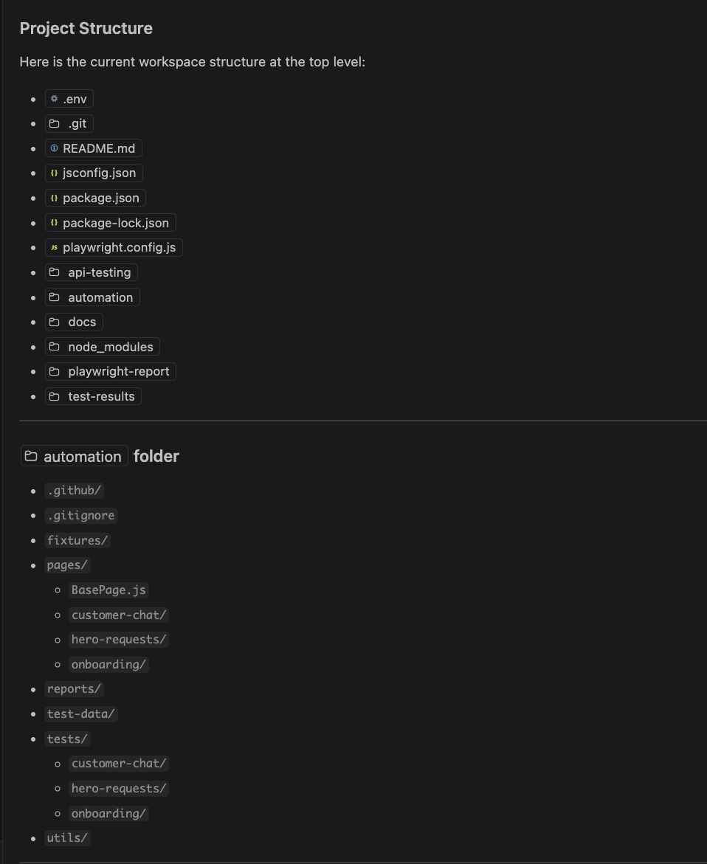

Sample Code:

Note: The actual website wasn’t used, and the locators included here are for demonstration purposes only.

Module 1 - Customer - Fills onboarding form
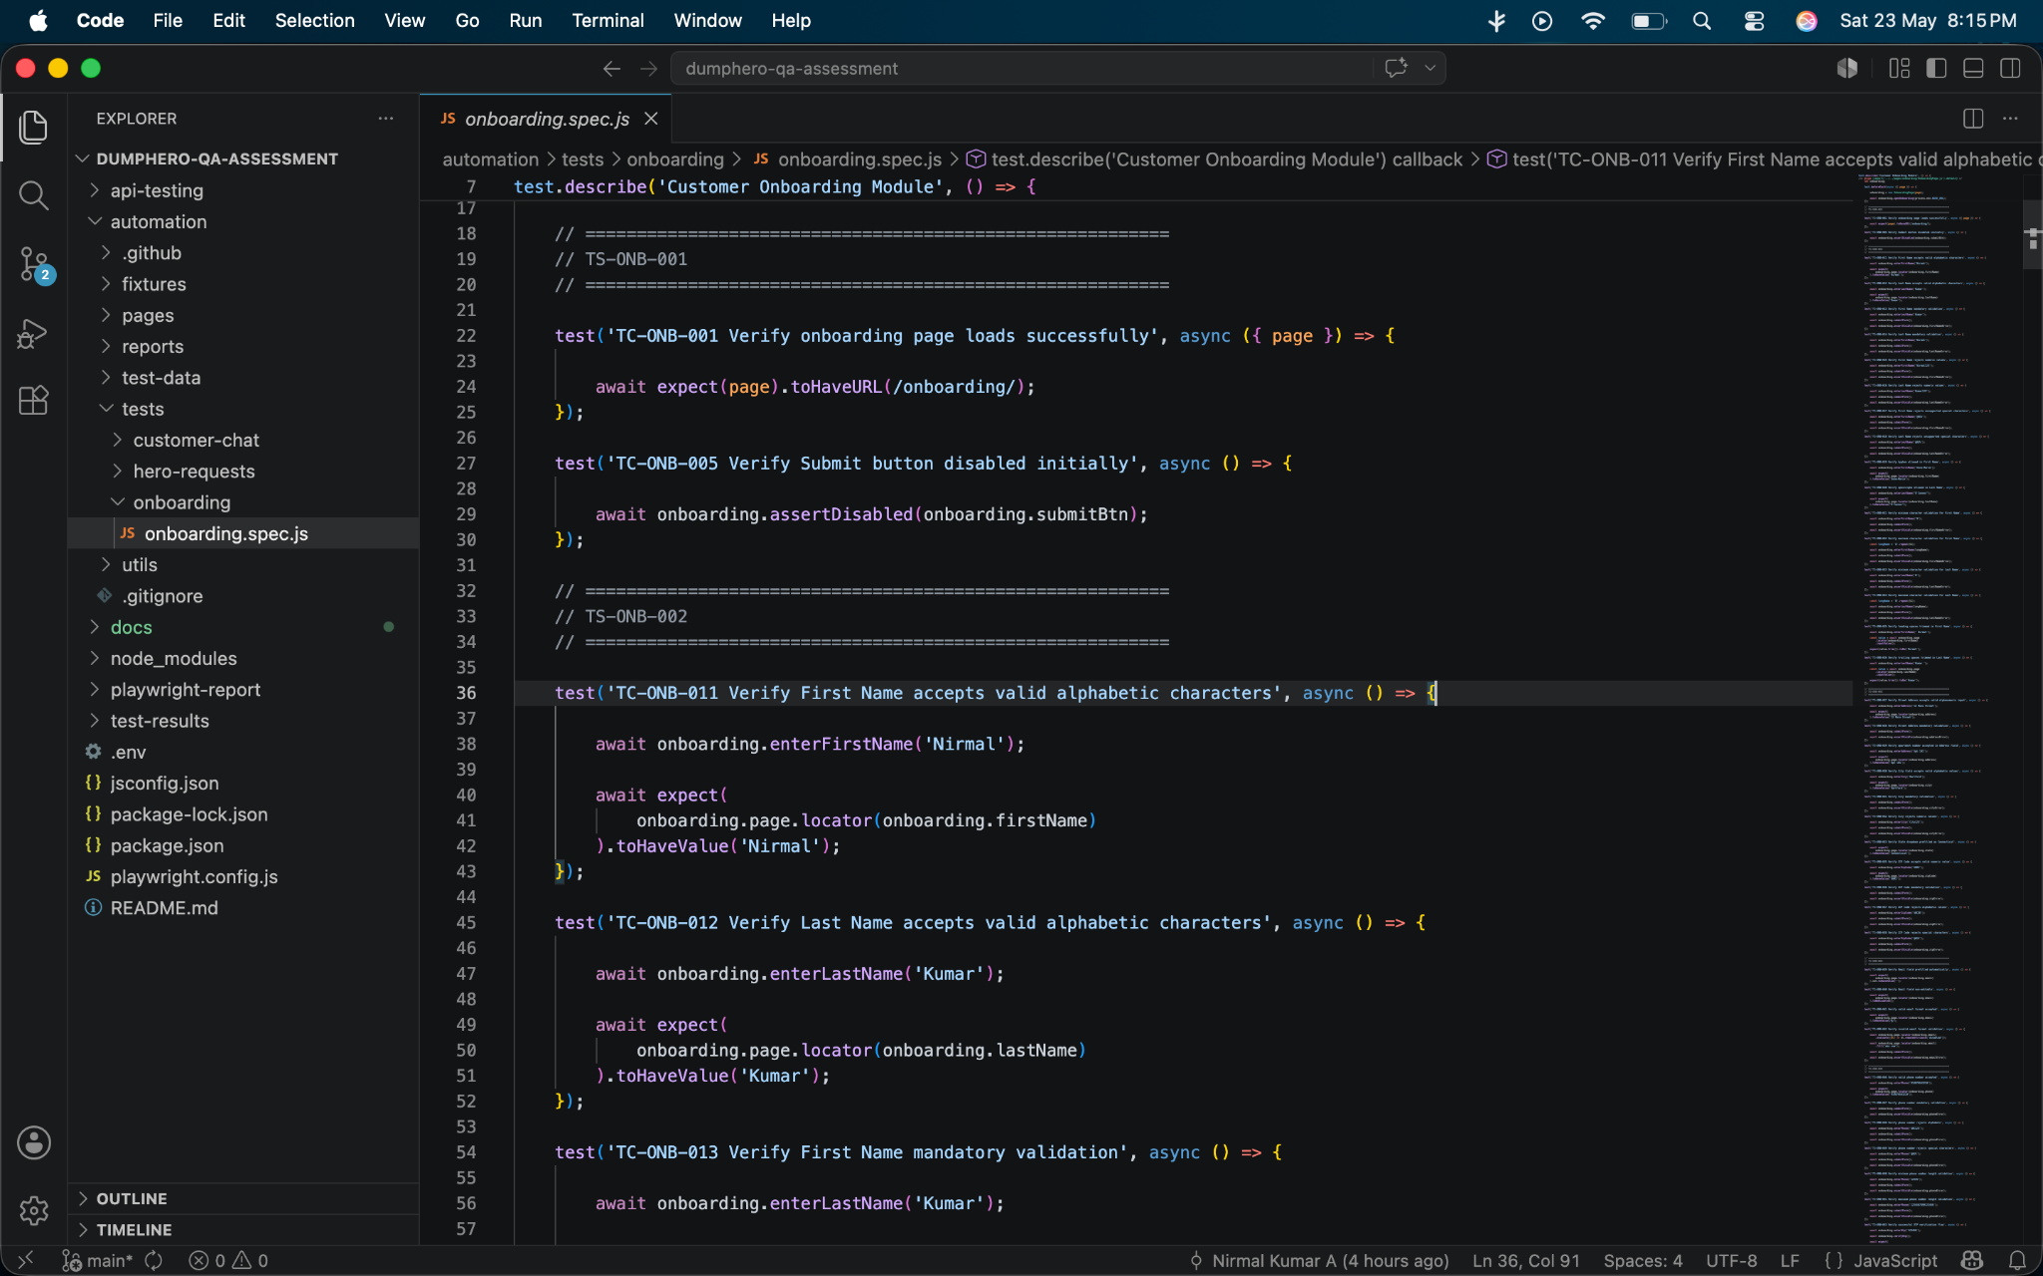
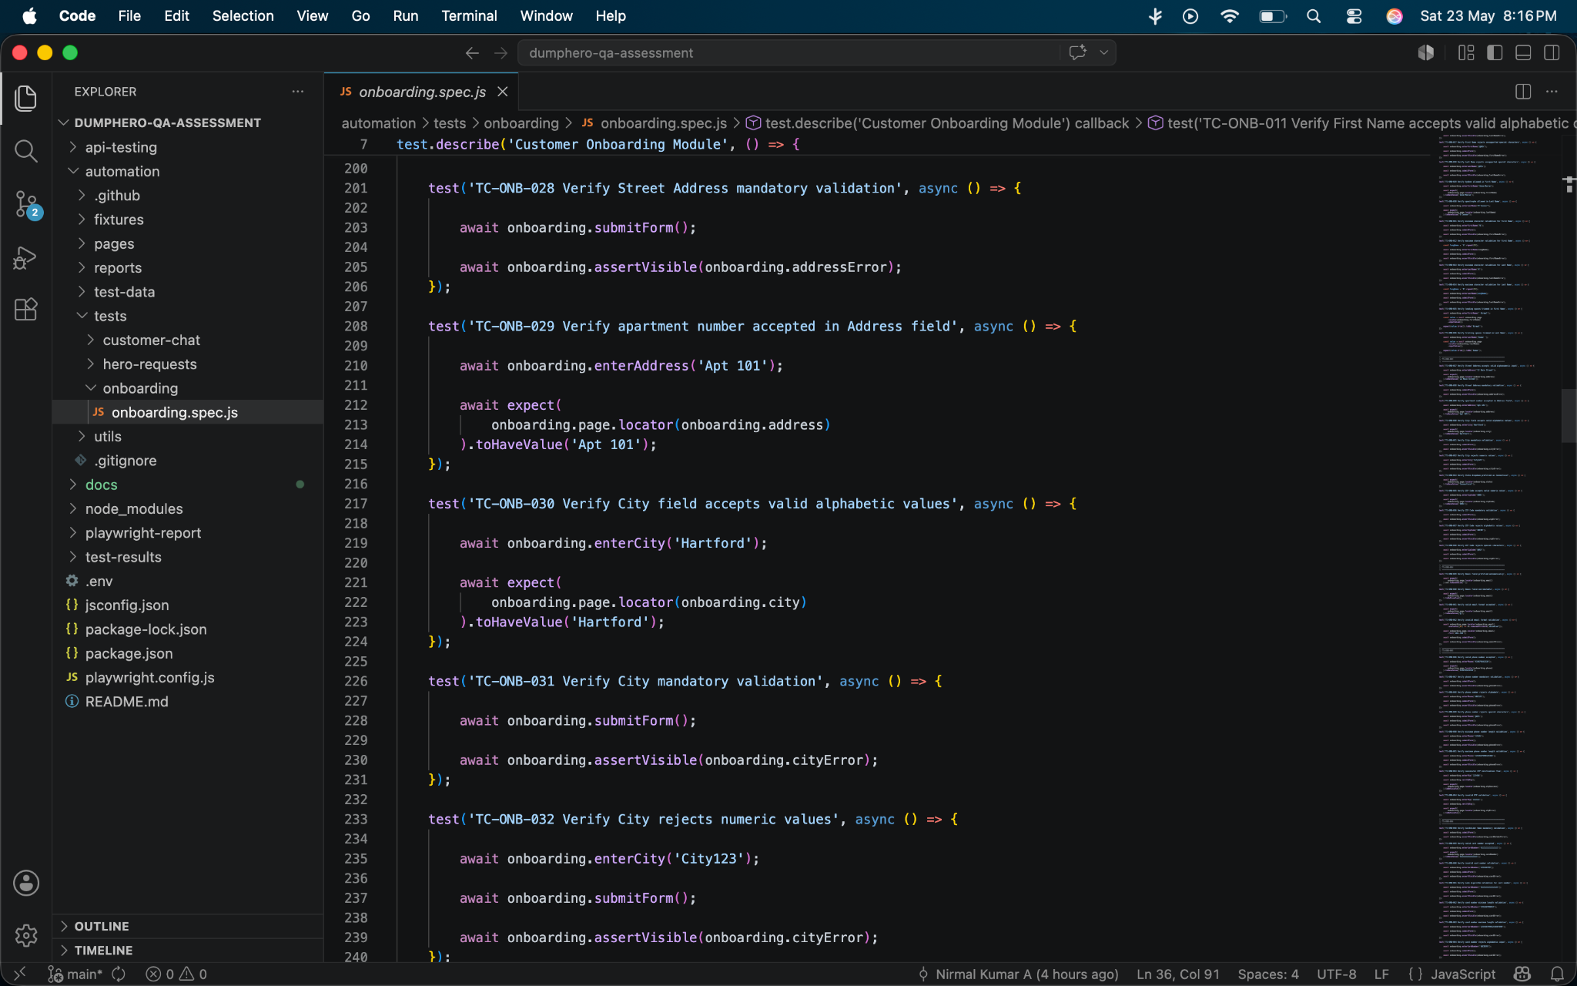

Locators (Pages):
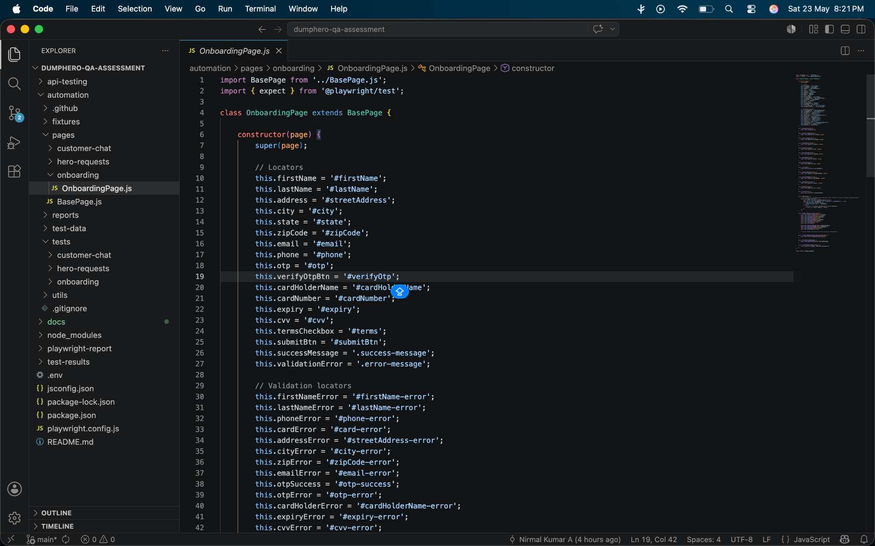
Module 2 - Customer - Viewing My Hero Requests

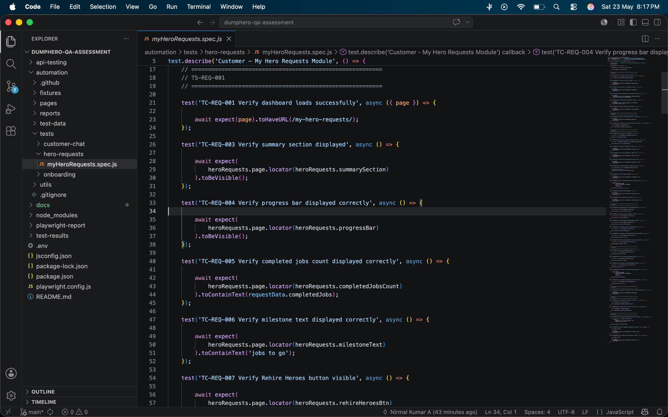
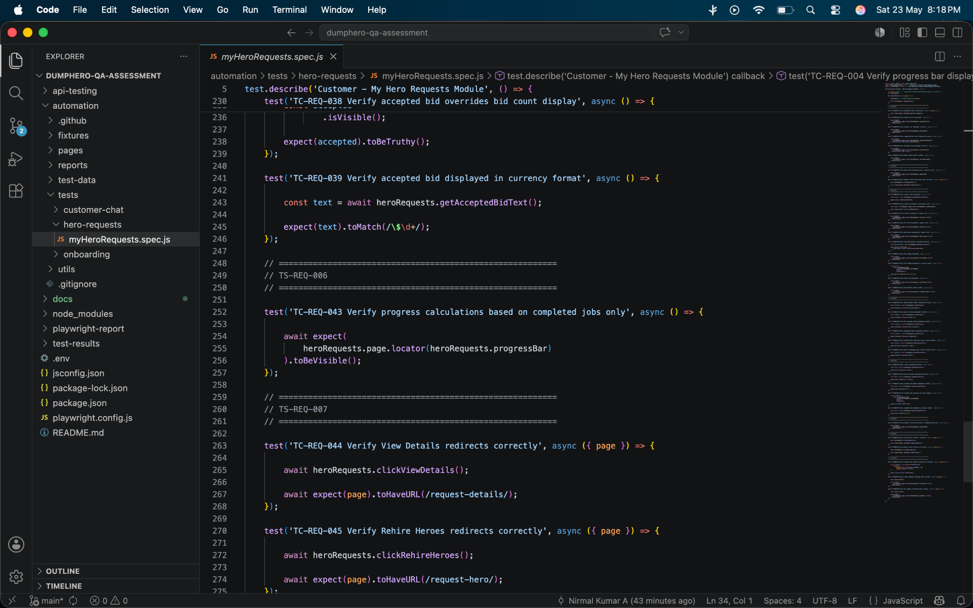

Locators (pages):
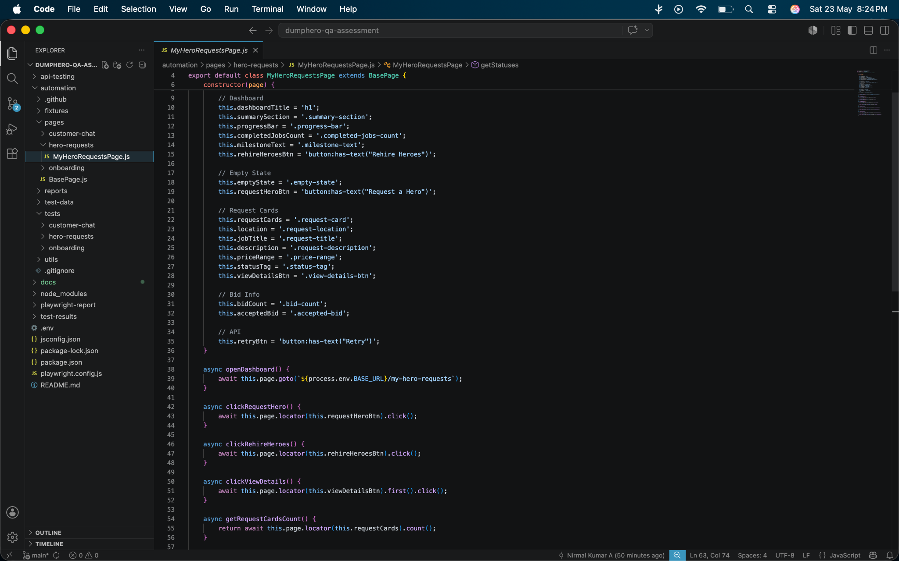

Module 3 - Customer - Chats with Hero post Bid Acceptance

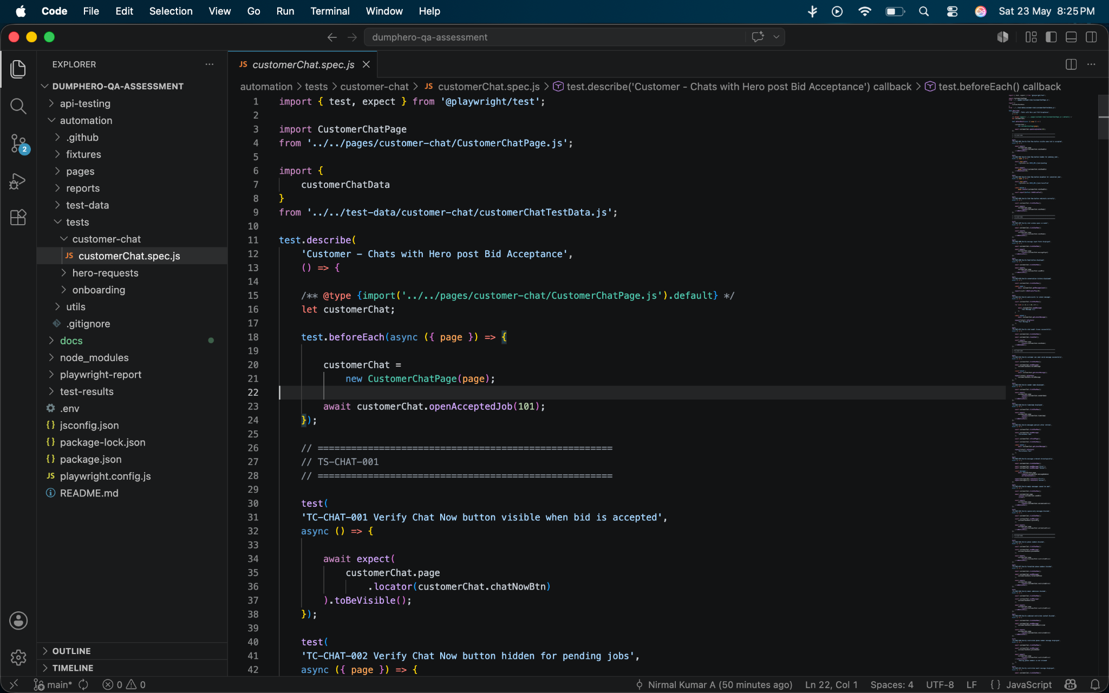
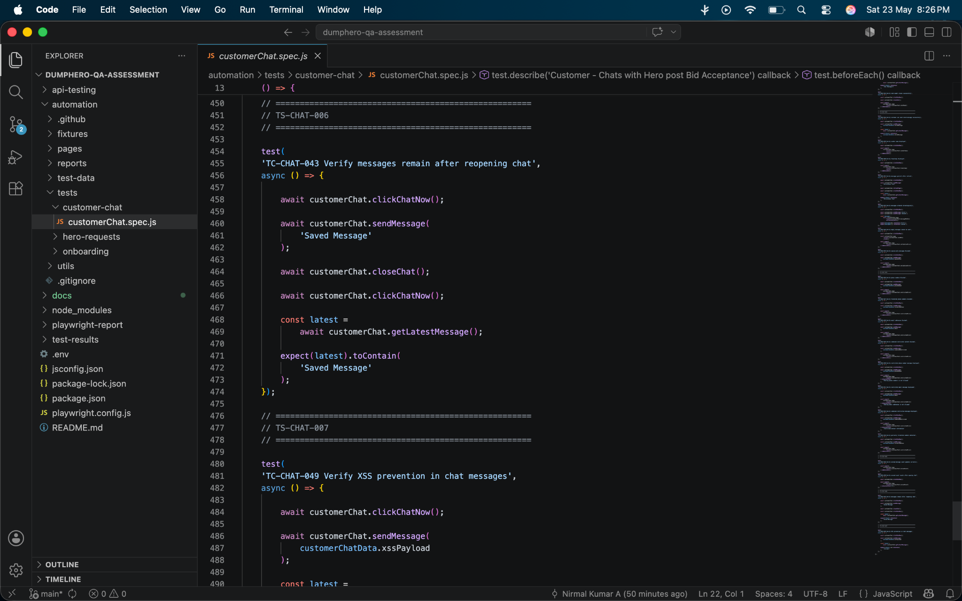
Locators (Pages):
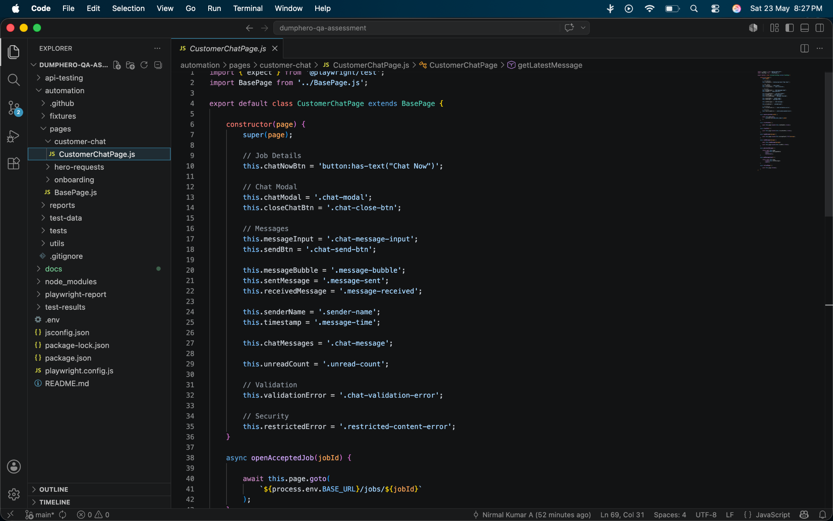

Sample Result Screenshots:

Note: The actual website wasn’t used here, which is why the tests are showing as failed. When executed against the original domain/website, the automation results would run correctly. The screenshots are only to demonstrate how the results would appear.

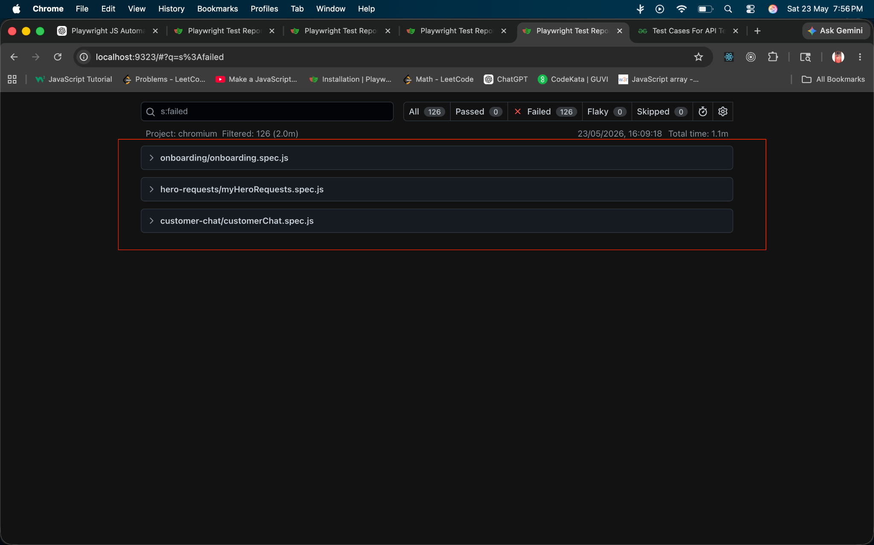

Module-wise result Screenshots

Module 1 - Customer - Fills onboarding form
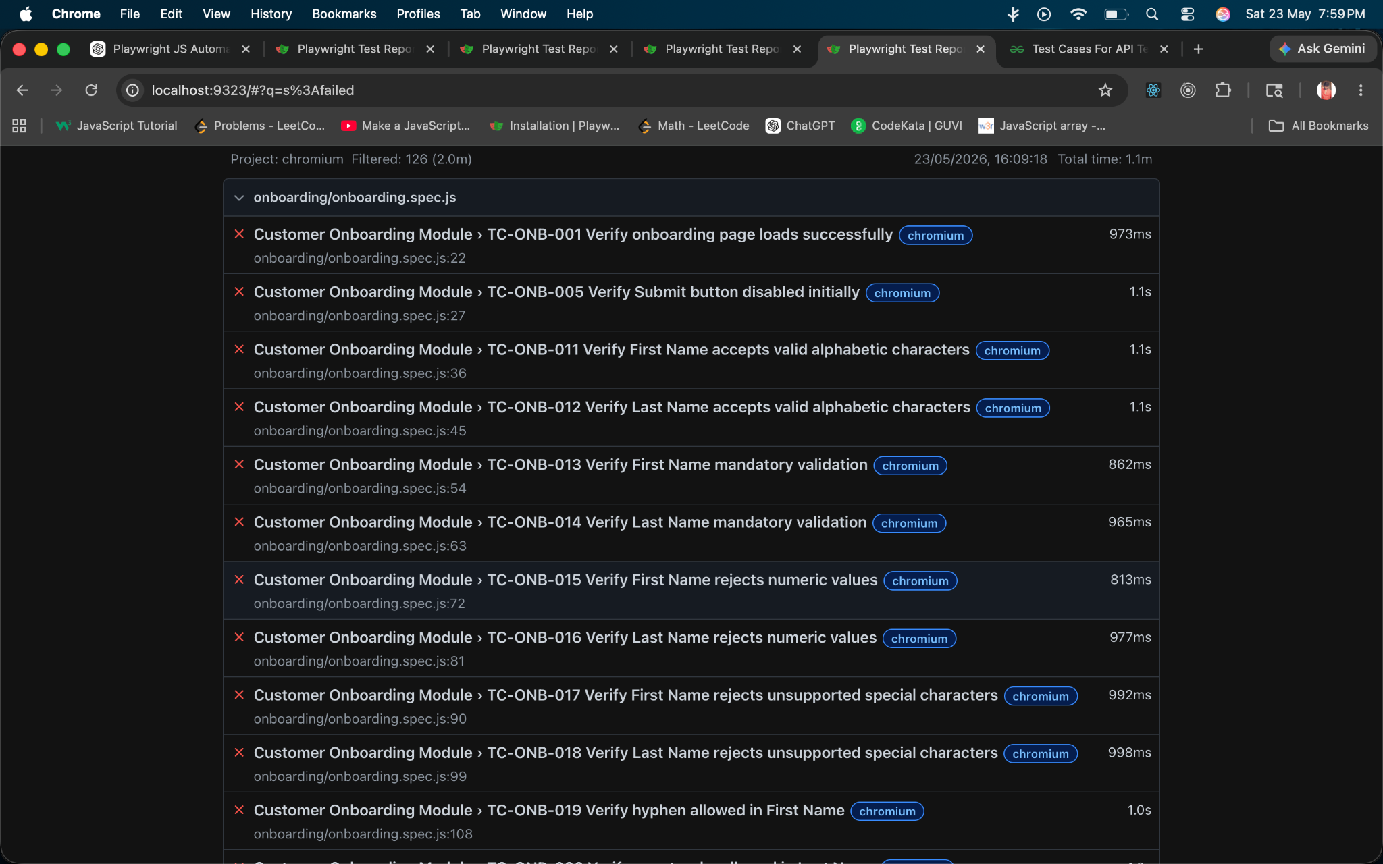

Module 2 - Customer - Viewing My Hero Requests
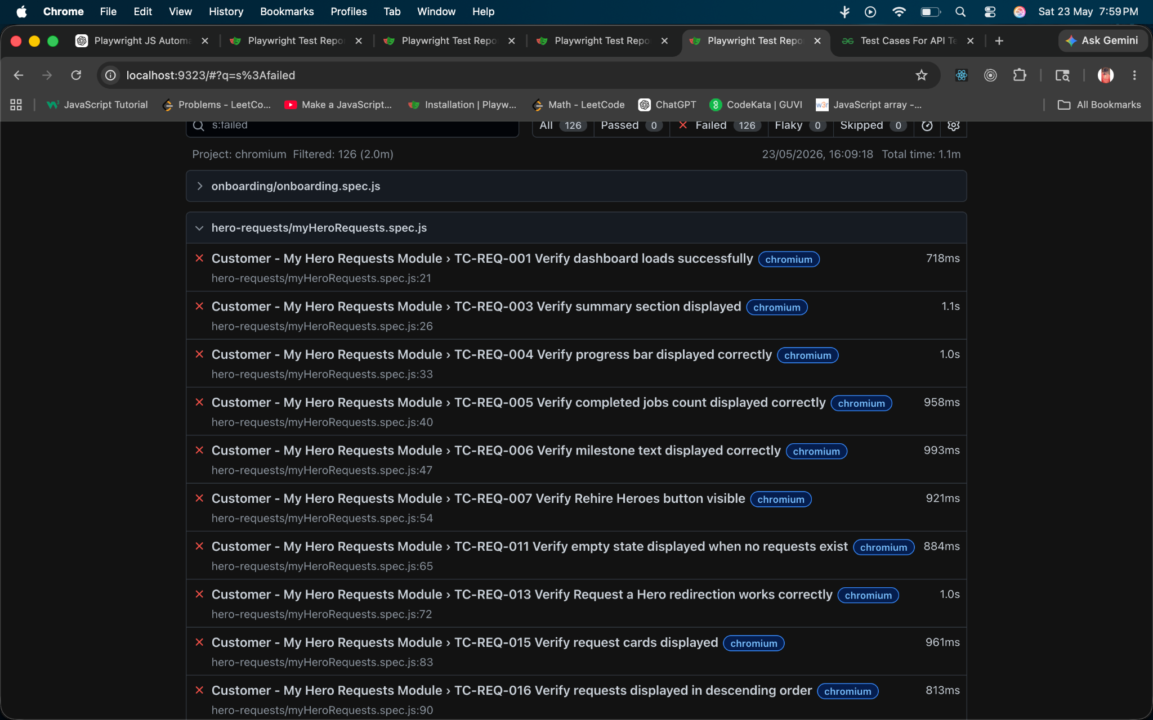
Module 3 - Customer - Chats with Hero post Bid Acceptance
